Student Id: 20079754
Course Title: M.Sc. Cyber Security
Lecturer Name: Swati Dongre
Subject Title: Advanced Programming Techniques
Assignment Title: CA_ONE_(30%)
No of Words:

Contents
1. Introduction 2
2. Question 1 – Phone Contact Book (C#) 2
3. Question 2 – File Extension Information System (C#) 3
4. Question 3 – TCP Client–Server Registration System (Python) 4
5. Question 4 – Hotel Room Price Scraper (Python) 6
7. Conclusion 8

1. Introduction
The activities I have done with CA_ONE have been listed in this report. The task will be divided into two sections that include Part I that will be on C and part II that will be on Python. All the questions addressed a specific skill in programming, which encompasses object-oriented programming, networking, file handling, databases, and web scraping. In this report, I will explain how I came up with every program, why some of the methods have been employed and how the systems operate. I have also provided the results of the findings in screenshots within this report.

2. Question 1 – Phone Contact Book (C#)
In this assignment, I developed a C# console-based contact management system. In this program I have had two classes; one was Contact and the second was ContactBook. Contact class contained the information about the first name, last name, company, mobile number, email and date of birth. Contact Book class deals with all the operations such as adding, displaying, updating and deleting contacts.
I took a List to store all the contacts since it is easy to add and remove items in the list. Validation of mobile number was also a priority and hence I ensured that the program accepts only a 9-digit number that is positive but not equal to zero. I also applied the encapsulation whereby I used the private fields and the public properties.
The menu provided gives the user options as to what he/she wants to do and all options work in the required manner in the question.
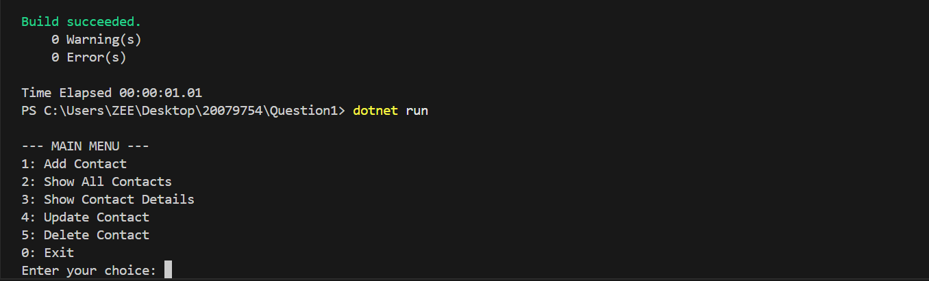
Figure 1: Main Menu

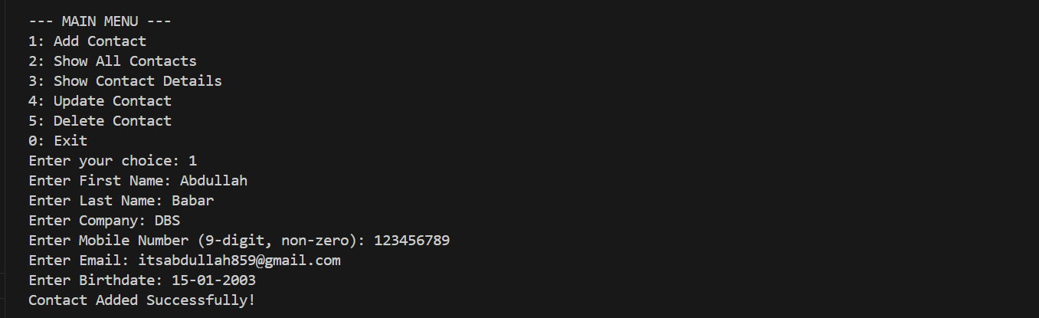
Figure 2: Adding Contacts

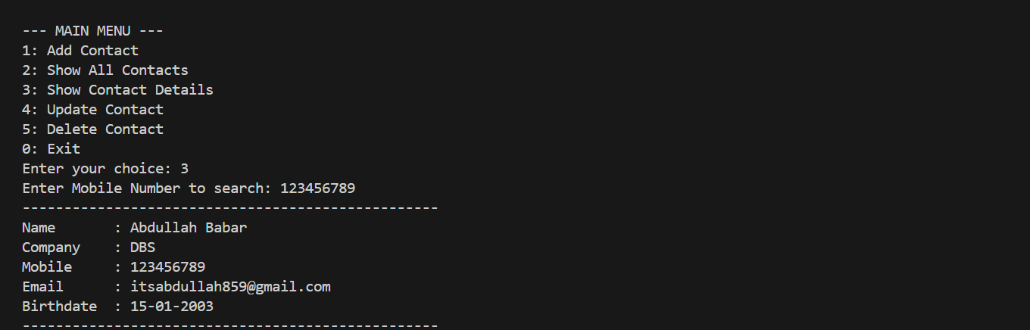
Figure 3: Viewing Contacts

3. Question 2 – File Extension Information System (C#)
The second C# code gives the user information about various file extensions. I maintained a Dictionary with at least 20 extensions and their definitions. A dictionary will be ideal in this case as it will be possible to quickly search by key (the file extension).
The program examines the dictionary when an extension is typed in by the user. In case of extension, then the meaning is printed. If it is not there, the program will show a friendly message as opposed to crashing. This presents graceful error processing, which the question requested.
The application is basic, but it shows effective data structure and input processing.

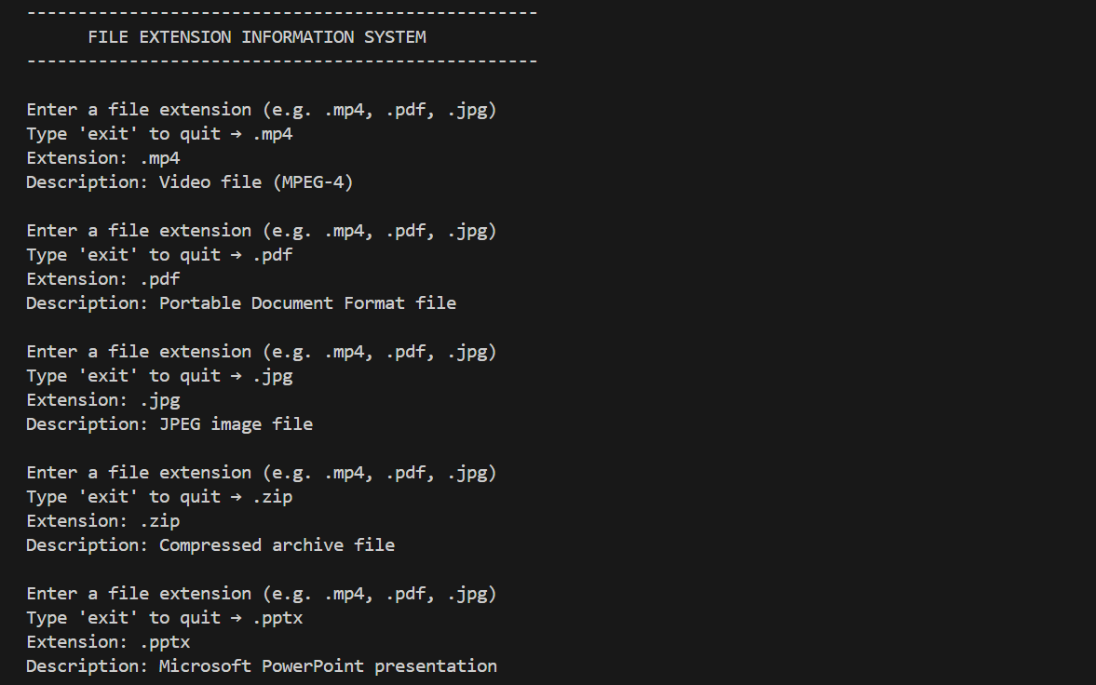
Figure 4: File Extensions Information

4. Question 3 – TCP Client–Server Registration System (Python)
The concept of networking I was required to use in this question was establishing a client server configuration using TCP. What the client gathers about the applicants includes their name, address, qualification, course of choice, and the date they want to join. The client contacts the server after gathering the data.
Data is sent to the server which in turn stores the data in a SQLite database and generates a distinct application number. This figure is relayed to the client to indicate to the user.
I selected SQLite since it is simple, lightweight and data is permanently stored in a file. Neither does it need a big database server to be installed. The reason why TCP was used is that it is reliable, connection-oriented and all the data should be delivered in proper form, which is critical in application records of the students.

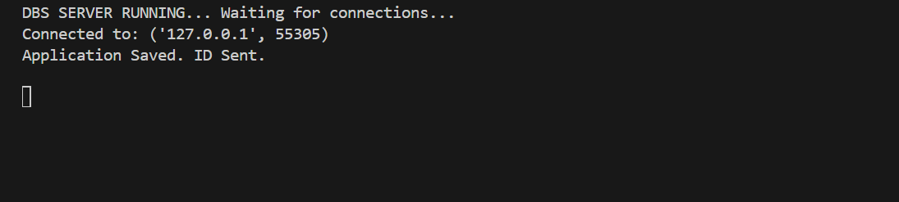
Figure 5: Server is waiting for connection

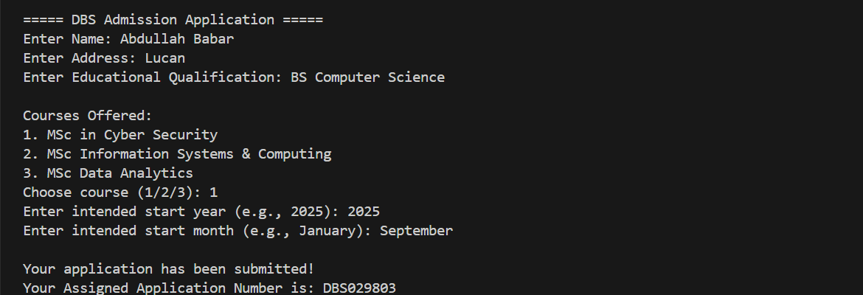
Figure 6: Client application has been saved

Figure 7: Server connected to client and application saved

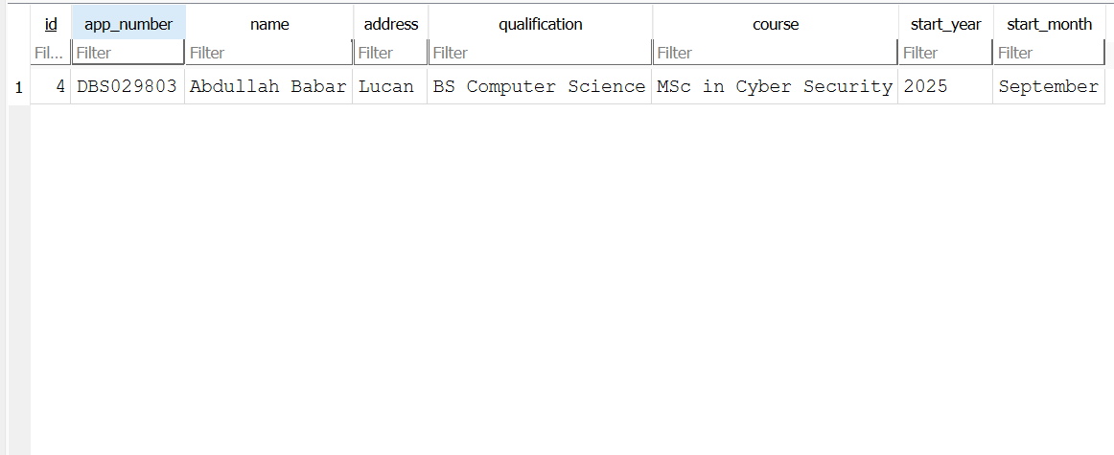
Figure 8: Showing Database Records

5. Question 4 – Hotel Room Price Scraper (Python)
In this task, I had to obtain the prices of hotel rooms in two hotels during a particular season. As live scraping may be subject to legal problems, I have used the following two HTML files (hotel1.html and hotel2.html) that is permitted.
I scraped the pages using the BeautifulSoup library of Python. From each file, I extracted:
- Room name
- Price
- Room description
- Room features
Once all the data was extracted, I saved all the data in a CSV file named hotel-prices.csv under the Python inbuilt CSV library.
I had to read the CSV file once more at the end of the program and presented all the data to the terminal. This will be compared easily between the rooms of both hotels.
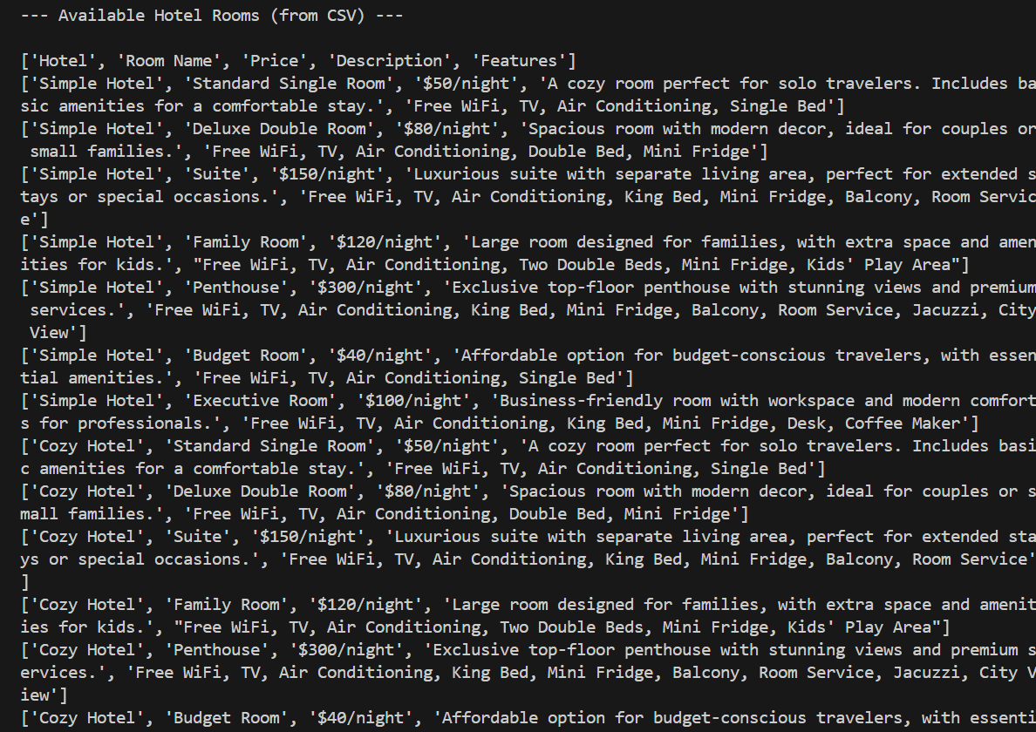
Figure 9: Terminal Output of Scraped Data

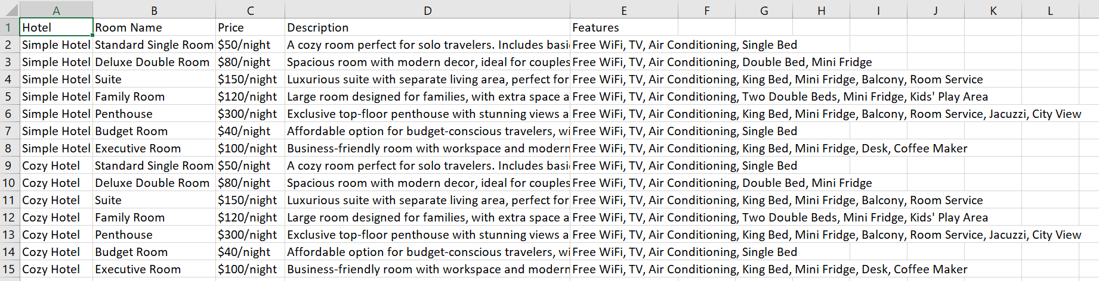
Figure 10: CSV File Preview

6. Challenges Faced
During the assignment, I encountered certain challenges:
- C# Input validation: ensuring that the mobile number was not empty but was a 9-digit number. I worked out this using my own validation routine.
- TCP Connection Errors: There were certain situations when the client failed to connect with the server in case the server was not started first. I was taught that it is always important to run the server first before the client.
- Differences in HTML Structure: The two hotel pages were not the same, so I had to create scraping code, which searched for tags and classes.
- Knowing CSV reading/writing: PythonLisp Python uses lists and rows to process CSV files and after practice, I learned the basics of CSV reading/writing.

7. Conclusion
All in all, this assignment enabled me to sharpen my skills in several areas such as C5 OOP, Python networking, dealing with databases, and web scraping. I was introduced to system design, data validation, permanent storage of information as well as processing of HTML files. The programs can be used successfully as per the requirements and the experience obtained will be useful in future programming tasks.

